SESSION 10 - UNION & UNION ALL Topics: Combine multiple tables. Difference between UNION vs UNION ALL Compatible column structures Demo: Combine online + offline sales tables.

Answer:

Introduction to UNION
- UNION is a SQL set operator used to combine the results of two or more SELECT queries into a single result set.
- Syntax
SELECT column1, column2
FROM table1
UNION
SELECT column1, column2
FROM table2;
- Important Rule
  - The SELECT statements used with UNION should have:
  - The same number of columns.
  - Columns in the same corresponding order.
  - Compatible data types.
- Example
SELECT customer_name
FROM AppOrders
UNION
SELECT customer_name
FROM InStoreOrders;
- The duplicate customer names are removed.

Introduction to UNION ALL
- UNION ALL also combines the results of multiple SELECT statements, but it does not remove duplicate rows.
SELECT column1, column2
FROM table1
UNION ALL
SELECT column1, column2
FROM table2;
- UNION ALL is useful when every record needs to be retained, including duplicate records.

Difference Between UNION and UNION ALL

Feature | UNION | UNION ALL
Combines multiple SELECT results | Yes | Yes
Removes duplicate rows | Yes | No
Keeps duplicate rows | No | Yes
Suitable for unique lists | Yes | No
Suitable when every record is required | Sometimes | Yes

- UNION uses duplicate removal by default, while ALL prevents duplicate removal

Tasks_01
CREATE TABLE AppOrders (
order_id INT PRIMARY KEY AUTO_INCREMENT,
customer_name VARCHAR(100),
amount DECIMAL(10,2),
order_date DATE
);
CREATE TABLE InStoreOrders (
order_id INT PRIMARY KEY AUTO_INCREMENT,
customer_name VARCHAR(100),
amount DECIMAL(10,2),
order_date DATE
);
INSERT INTO AppOrders
(customer_name, amount, order_date)
VALUES
('Hitesh', 450.00, '2026-09-01'),
('Rahul', 320.00, '2026-09-02'),
('Priya', 550.00, '2026-09-03');
INSERT INTO InStoreOrders
(customer_name, amount, order_date)
VALUES
('Amit', 280.00, '2026-09-01'),
('Neha', 620.00, '2026-09-02'),
('Rahul', 320.00, '2026-09-03');

Output
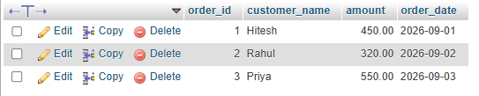

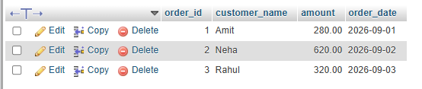

Tasks_02
SELECT customer_name
FROM AppOrders

UNION

SELECT customer_name
FROM InStoreOrders;

Output
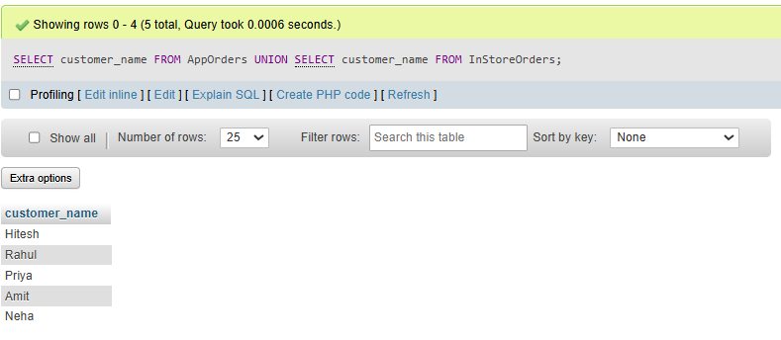

Tasks_03
SELECT
order_id,
customer_name,
amount,
order_date
FROM AppOrders

UNION ALL

SELECT
order_id,
customer_name,
amount,
order_date
FROM InStoreOrders;

Output
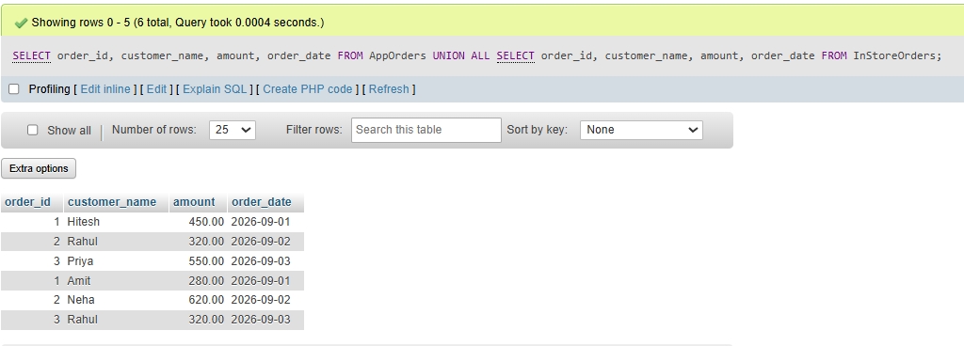

Tasks_04
The difference can be represented as:
AppOrders: | InStoreOrders:
Hitesh | Amit
Rahul | Neha
Priya | Rahul
# Using UNION
Hitesh
Rahul
Priya
Amit
Neha
Total = 5
#Using UNION ALL
Hitesh
Rahul
Priya
Amit
Neha
Rahul
Total = 6
Compatible Column Structure
- For UNION and UNION ALL, the corresponding columns should have compatible data types and the same number of columns.

Conclusion
- UNION was used to generate a unique list of customers, while UNION ALL was used to display every order, including duplicate customer records. This concept is particularly useful in data analytics when information is stored separately by sales channel, branch, region, platform, or business unit.

